**Fronted Development With React.js**

**Project documentation. Format**

**Rhythmic Tunes: your melodic companion**

1. **Introduction :**

**Project Title : Rhythmic Tunes your melodic companion**

**Team ID : NM2025TMIV39091**

**Team Members :**

**Team Leader Name: M.G.Gopika**

**Mail ID:** [**24bsccs23@cttewc.edu.in**](mailto:24bsccs23@cttewc.edu.in)

**Team Member Name : S.kamali**

**Mail ID:** [**24bsccs07@cttewc.edu.in**](mailto:24bsccs07@cttewc.edu.in)

**Team Member Name: G.Harinikarthiga**

**Mail ID:** [**24bsccs09@cttewc.edu.in**](mailto:24bsccs09@cttewc.edu.in)

**Team Member Name :C.DhanaLakshmi**

**Mail ID:** [**24bsccs01@cttewc.edu.in**](mailto:24bsccs01@cttewc.edu.in)

**2. Project Overview :**

* **Purpose : Rhythmic Tunes is a modern music streaming application designed to offer users an immersive listening experience. It’s provides the vast collection of songs, playlists and personalized and recommendations. The app ensures a seamless interface for browsing, discovering and enjoying music.**
* **Features :**
  + **Browse Songs by Genre, Artist or Album.**
  + **Personalized Playlist Creation**
  + **Search Functionality with Real-Time Suggestions**
  + **Media Player with Play /Pause ,Next Previous, and Volume Control**
  + **Bookmark Feature for Saving Favorite Tracks**
  + **Light/Dark Mode for Improved User Experience**
  + **Responsive Design for Desktop and Mobile Devices**

**3.Architecture :**

**Component Structure :**

* **App .js __ Root Component Structure managing layout and routing**
* **Header .js __ Navigation bar with search Functionality**
* **SongList .js __ Display a list of available Songs**
* **SongCard .js __ Individual card showing songs details and Controls**
* **Playlist .js __ manager user created Playlist.**
* **Media Player .js __ provides audio play back Controls**
* **Footer .js __ Display copyright and app links.**

**State Management :**

**Context API _ used for managing the global States such as theme Preferences, playlists data, and Bookmarked songs.**

**Routing :**

**React router : Implemented for seamless navigation between the music categories, playlists view, songs details**

**4. Setup instructions :**

**Prerequisites :**

* **Node. Js ( v18 or higher)**
* **Npm or yarn**

**Installation :**

1. **Clone the Repository :**

**’’’ bash**

**Git clone** [**https://github.com/darunraj0071/Rhythmic**](https://github.com/darunraj0071/Rhythmic) **_ Tunes. Git**

**Cd Rhythmic Tunes**

**’’’**

1. **Install dependencies :**

**’’’ bash**

**Npm Install**

**’’’**

1. **Create .’env’ file (for API keys for environment variables):**

**’’’env**

**REACT_ APP_MUSIC_ API_ KEY = your _ api_ key_ here**

**’’’**

**4.Run the Application :**

**’’’Bash**

**Npm start**

**’’’**

**5.Folder Structure**

**/src**

**| ___/Component**

**| ___ Header .js**

**| ____songList .js**

**| ___songCard .js**

**| ___playlist .js**

**| ___mediaplayer .js**

**| ___ Footer. Js**

**|-___/pages**

**| ___ Home .js**

**| ___ discovering. Js**

**| ___ playlists. Js**

**| ___favorites .js**

**|-__/ assets**

**| ___ images**

**| ___ icons**

**| ___ styles**

**| __/utils**

**| ___api.js**

**| ___ helpers .js**

**|___ constants .js**

**| ____app .js**

**| ____ index .js**

**6.Running the Application**

**Frontend server command :**

**’’’bash**

**Npm start**

**’’’**

**7. Component Documentation**

**Key Components :**

* **Header: provides navigation, search Functionality, and theme toggling**
* **SongList: Display categories or search songs in a Structured format**
* **SongCard : Display Individual songs details with Play/Pause Controls**
* **Media Player: Controls audio play back,Volume, and track navigation**

**Reusable Components:**

* **Button component: used for action like “play” ,” Pause “,or “add to playlists**
* **Local State: Managed using react’s useState() for tracks progress, user interaction, and dynamic updates**

**9. User interface:**

* **Clean ,minimalistic UI designed for seamless navigation**
* **Fully Responsive layout with smooth transitions**
* **Light/Dark Mode toggle for personalized visual comfort**

**10. Styling**

**Css Frameworks/Libraries**

**Tailwind css _ used for fast and modern UI design**

* **Theming :**

**Integrated theme switcher for enhanced user experience**

**11. Texting**

**Testing Strategy:**

* **Jest for unittesting**
* **React Testing Library for comprehensive component testing**

**Code coverage:**

* **Ensured high code coverage with Jest reports.**

**12. Screenshots or Demo**

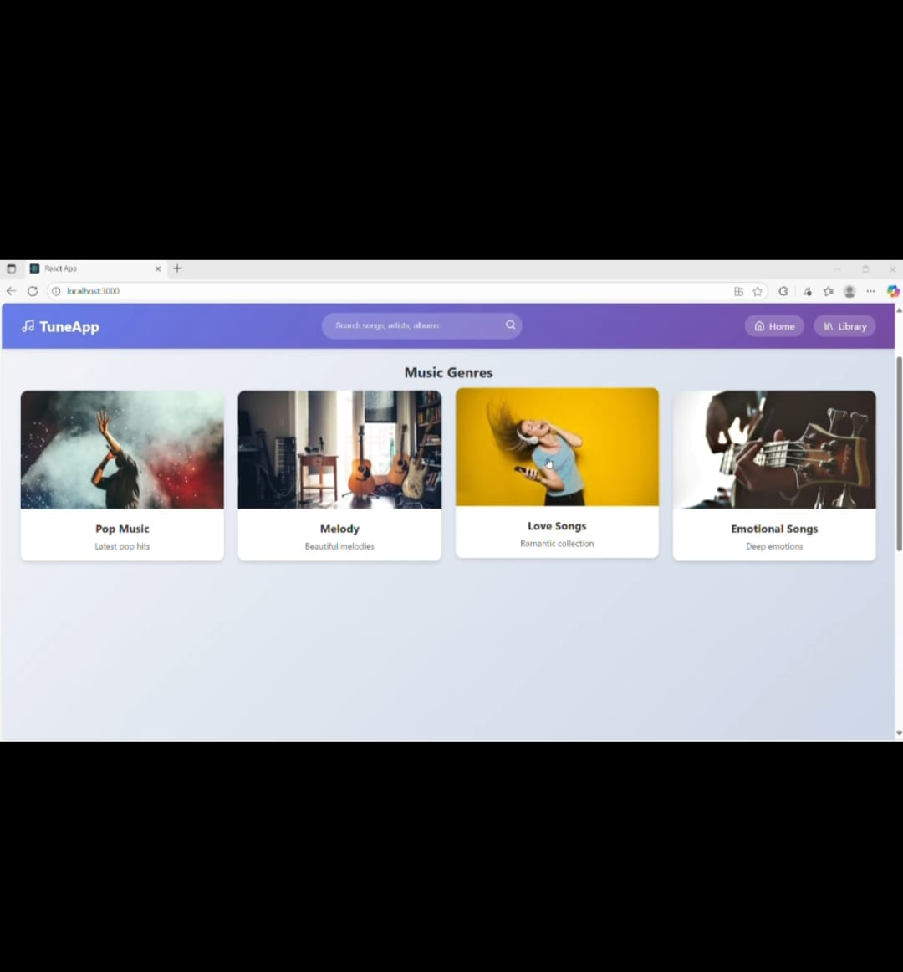

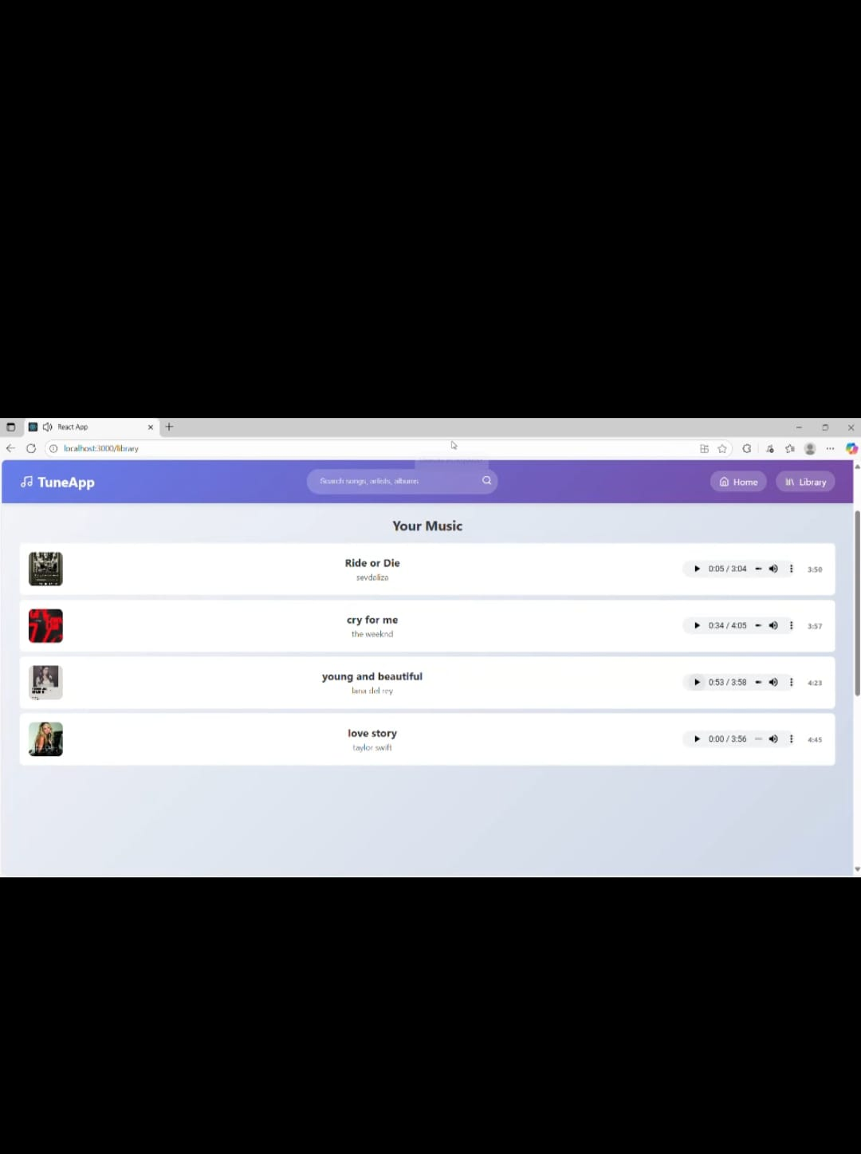**demo**

**13.known issue**

* **Occasional delays in song loading due to API limits**
* **Playlist feature may require additional optimization for large data sets**

**14. Future Enhancements**

* **Implemented user Authentication for personalized playlists**
* **Introduce Podcast and Radio Streaming Integration**
* **Social Sharing Feature for tracks and playlists**
* **Offline Mode for saved playlists without and internet connection**